Driver Setup - From your Window desktop type **Classic** in the *‘Search the web and Windows’* input in the lower left corner of your monitor.



Select the RSLinx Classic Desktop application.

RSWho - Select *Communications* then *RSWho*.

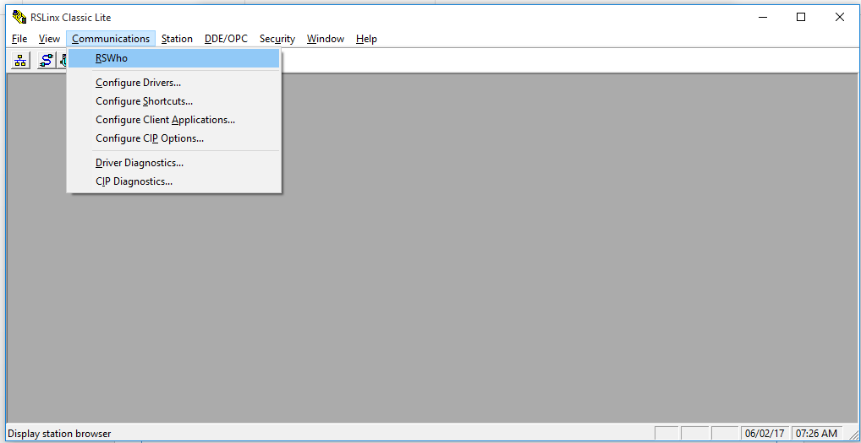

RSWho Results - Select the AB_ETHP_2, Ethernet card. This is the network interface card (NIC) on the side of your PC. A list of IP addresses will show that have red Xs over them. Those where previously connected devices that are currently unreachable. In the status bar a message should be displayed that states

***Browsing – node xxx.xxx.xxx.xxx found***

where the Xs will correspond to your PLC’s IP address. Communication is established. Nothing further needs to be done. You may close RSLinx Classic.

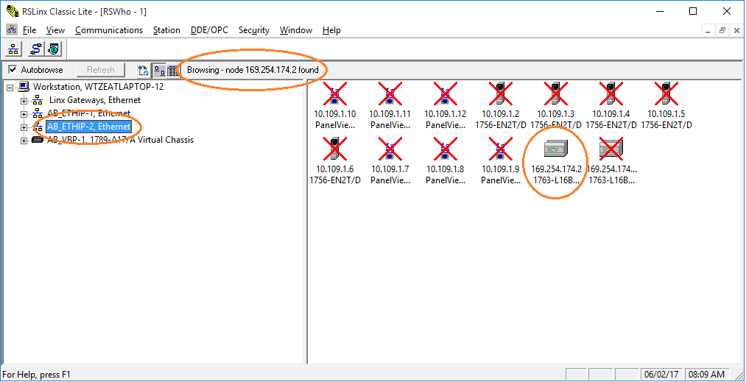

# RSLogix 500

From your Window desktop type **RSLogix** in the *‘Search the web and Windows’* input in the lower left corner of your monitor.

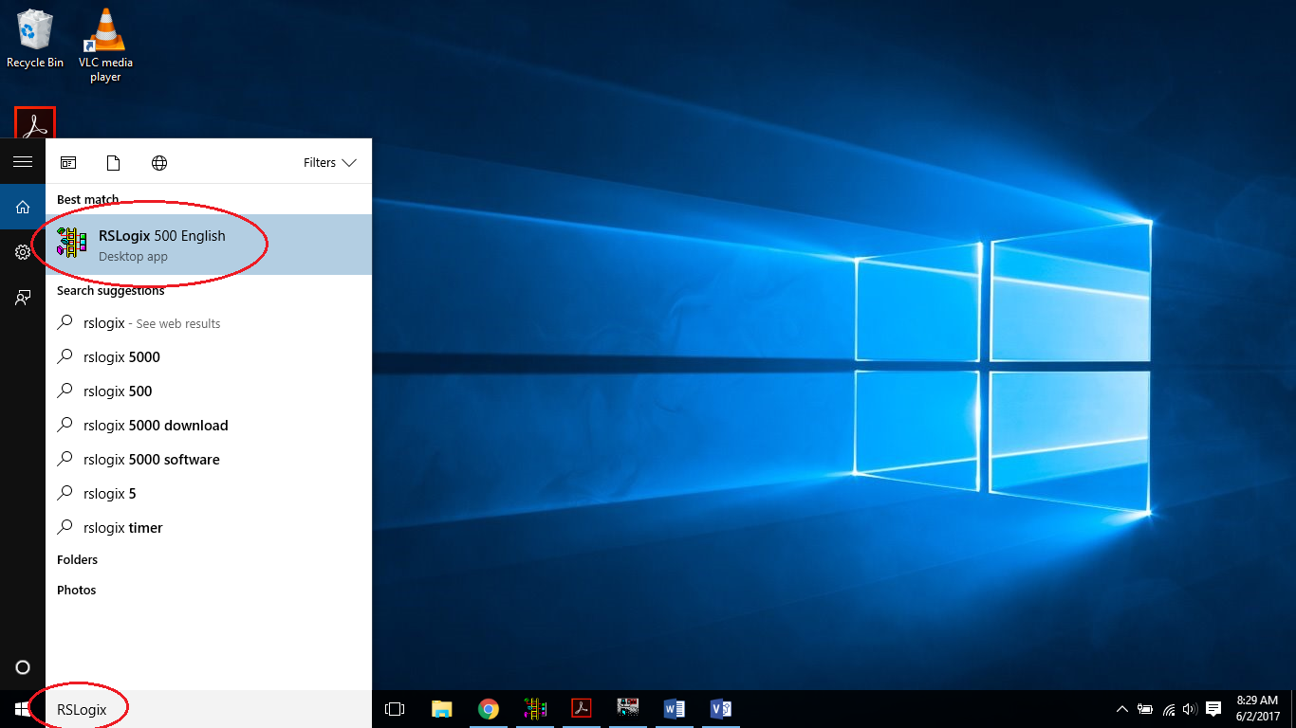

## RXLogix Who Active Go Online

Select *Comms* then *Who Active Go Online.*

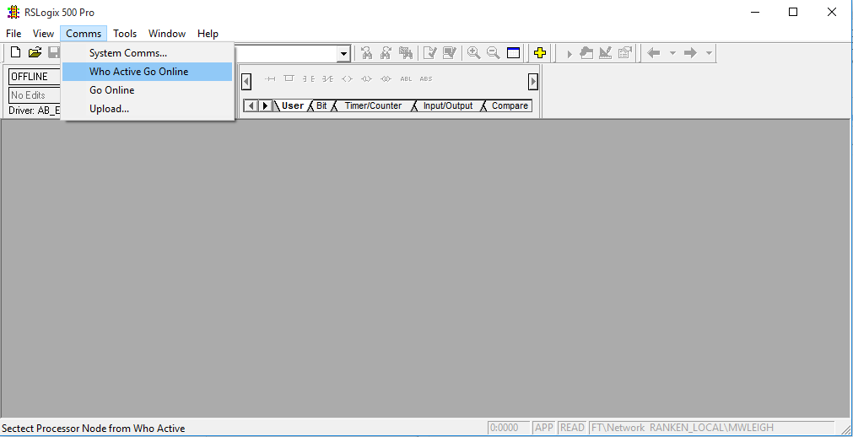

## RSLogix 500 Communications

Below is the result of the Comms .> Who Active Go Online

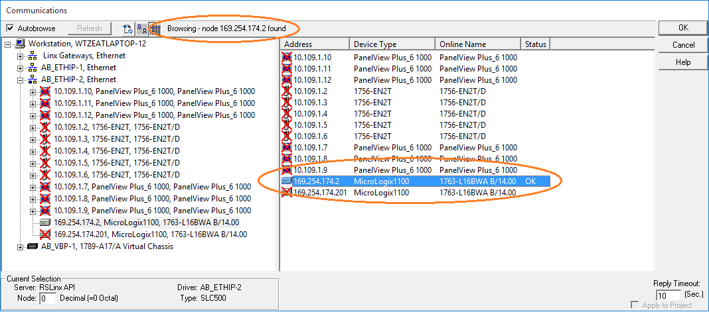

Look for your PLC’s address. It should not have a red X in it’s icon. Select your PLC’s address in the right window pane and press [OK].

### Going to Online Programming State

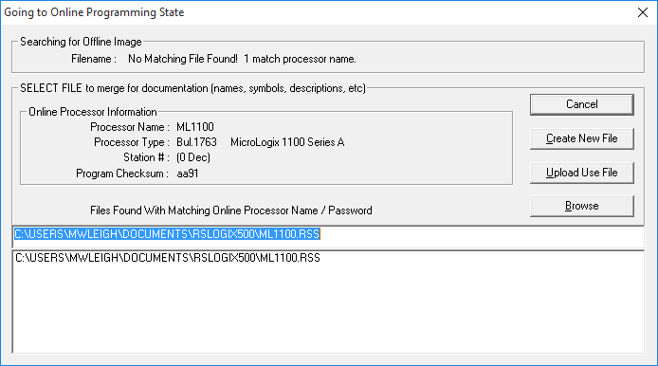

Select [Create New File].

# RSLogix 500 New Program

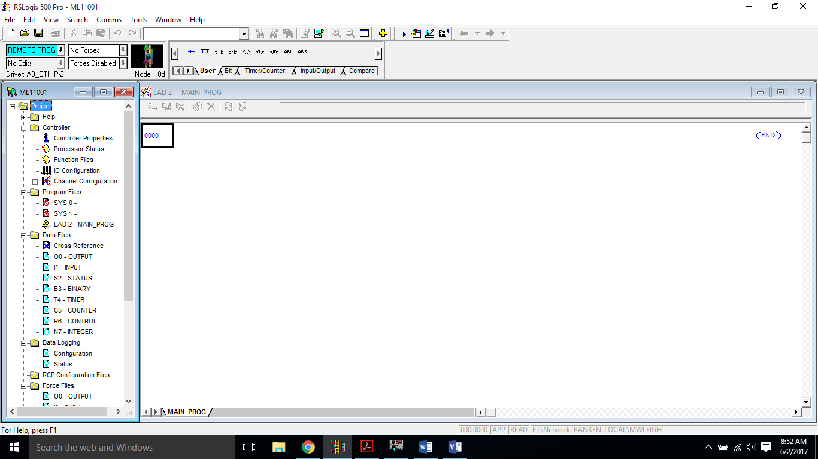

You may now begin programming.

# Restore IP Configuration

Perform the following steps described earlier in the document;

1. Connect PC to PLC
2. Disable Wireless
3. Power-up PLC
4. Open BOOTP Server
5. Open previously saved Configuration file

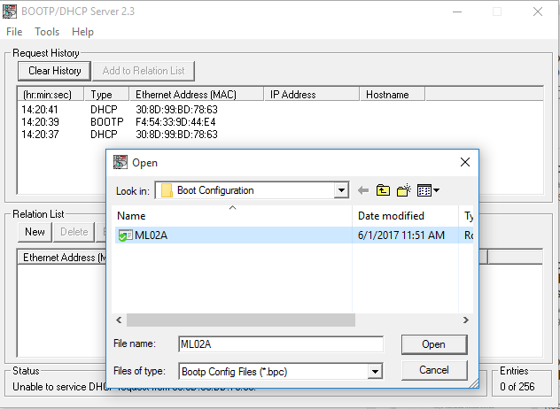

## Restore PLC IP

Once the configuration file is open, the server will establish communications with the PLC (via the MAC address) and assign the IP address configured in the Relation List. You **do not** need to select your controller in the Relation List and enable BootP again. The BOOTP Server is designed to “serve-up” all the IPs in it’s Relation List, but since we only have one PLC in the configuration file, it’s task is quite simple.

